**Preliminary Design Review**

**Objective**

The Preliminary Design Review (PDR) is a refinement of the information presented in your Conceptual Design Review. Its primary purpose is for you to show your ability to communicate your work to others effectively in a conference-style presentation form. Its secondary purpose is to give you an opportunity to present your project concept and implementation progress and issues to the class and instructors.

**Presentation**

Each team will have 22 minutes total, 15 minutes for presentation followed by 7 minutes of Q & A.  Use, but do not exceed or fall short by more than two minutes, your full 15 minutes of presentation time - there is plenty to describe. Plan on using a team laptop to present, since ensuring that videos, or animations, or other content elements run on another laptop can be tricky. However, have one team member upload your presentation to Canvas so we have a copy for archival purposes and all teams have the same deadline.

**Examples**

Top MRSD PDR presentations from last year are posted along with this assignment. These are not perfect models, in part because the content guidelines are continually refined - the ultimate guide is the PDR Guidelines document you are reading now. IEEE International Test Conference guidelines are also attached for general guidance on how to prepare a good slide presentation.

**General guidelines**

* A reasonable rule of thumb for presentations is one slide per minute, but this will depend on various factors, such as whether you have animations, so be guided by the time limit, and create however many slides fit into that.
* Everyone on the team should play a role in the presentation.
* Attend all presentations so all teams have an audience. We will start on time, so ***be there a few minutes early.*** It goes without saying that you must be there for your team’s presentation. If you are absent on the day you are not presenting, you will lose 2 out of the 20 possible points.
* Do not use physical props to describe concepts. The idea is to give a talk as you would at a technical conference, or within a company to your CEO or CTO; in both cases, brevity and focus are crucial.
* Use videos, animations, and any other illustrative presentation techniques that Powerpoint or other presentation software allows.
* Assume a general technical audience; i.e., don't assume your listeners have special knowledge.
* In general, and especially for elements that would be too lengthy if presented in full (e.g. system requirements or multi-level functional architecture), pretend you are presenting to your company's CEO to get permission to build the system - what do you think he or she would like to hear most?

**Delivery**

You will be graded on delivery (item 9 in the rubric at the end of this document) as well as content. Practice as a team ahead of time; include the practice of smooth handoffs from one speaker to another. Briefly introduce your team members by name, adhere to the length limit, speak clearly and without stumbling, face the audience, keep your hands out of your pockets, and be prepared to answer questions crisply and coherently.

**Content**

The Preliminary Design Review (PDR) consists of the following components in the indicated order:

1. Project description
2. Use case
3. System-level requirements
4. Functional architecture
5. Cyberphysical architecture
6. System/subsystem descriptions
7. Current system status
8. Project management

Items 1-5 should involve refinements/revisions of what you presented in your CoDR. Refer to the CoDR Content Guidelines for additional details on their contents. Items 6 & 7 are the meat of the PDR: item 6 gives a technical description of the final desired state of your system/subsystems and how they will work together, and item 7 gives a parallel description of where each of them stands today. The various parts of item 8 are important in showing your planning and execution process.

Component descriptions

1. Project description. This is a **refined** project description consisting of user needs and your proposed method of meeting them. It focuses on end results, not the details of the technology.
2. Use case. Give a brief refined use case coupled with a **graphical representation** of the system in its **use case/mission environment**. The use case should make clear what your system will do.
3. System-level requirements
4. Summarize your system requirements.
5. Identify any requirements changes since the CoDR with justification for the changes.
6. Functional architecture
   1. This is a block diagram showing your system’s **major functions and the flow** (information, energy, material) between them down to one level below the one presented in the CoDR. Limit the level of detail so the architecture is visible and intelligible.
7. Cyberphysical architecture
8. This is a block diagram showing your system’s **major cyberphysical (hardware and software) components and the flow** (information, energy, material) between them. Limit the level of detail so the architecture is visible and intelligible.
9. System/subsystem descriptions. Describe and depict the key technical aspects of your system and each major subsystem as you expect it to appear and function in your final system.
   1. This should start with an ***overall system graphical representation*** and include CAD drawings, photos, or other graphical representations of your subsystems.
   2. It should ***not*** consist entirely of block diagrams or simply be zoom-ins on components of your functional or cyberphysical architecture block diagrams.
10. Current system status. Describe and depict what you have developed so far.
    1. This should run parallel to the subsystem descriptions by giving the current progress towards the final desired state of each of the major subsystems. Use videos or simulations for moving parts.
    2. You may combine the subsystem descriptions (Item 6 above) and current system status if desired, but in that case make clear the difference between the desired final state and the current status.
11. Project management
12. Work Breakdown Structure. Present a high-level **summary** of the three-level Work Breakdown Structure you developed in the Systems Engineering class. Save the WBS details for the Critical Design Review Report (document) due at the end of the semester.
13. Schedule. Don’t present anything that is too detailed to see or talk about, such as a detailed (as opposed to a summary and readable) Gantt Chart. Answer these key questions:
    1. What are the major system development milestones in the remaining schedule?
    2. Are you behind, ahead of, or on schedule? If behind, how will you catch up?
14. High-level test plan
    1. Use a table to present your test plan as a set of capability milestones for the three (3) remaining Progress Reviews (PR) in the spring semester (PR 3, 4, and 5-6, since 5-6 are the Spring Validation Demonstration and its encore) and for roughly the ends of each of the four (4) months (Aug-Nov) in the fall semester. Indicate briefly how these capabilities will be tested.
    2. Spring and Fall Validation Demonstrations (SVD/FVD). These are the final two (2) Progress Reviews in each semester, to be presented in lab demonstrations lasting no more than 30 minutes per team. Include them in summary form in the table above, but also describe them separately in somewhat greater detail than the other capability milestones, including these essential elements:
       1. The test location.
       2. The sequence of events.
       3. The quantitative performance metrics that your system will be measured against.
       4. Graphical depiction(s) to illustrate your SVD/FVD.

The SVD/FVD you present in the PDR should be as concise, clear, and graphical as possible. You will provide a more detailed description in the SVD/FVD one-pagers you are also required to submit as part of the PDR assignment.

1. Budget. Answer these key questions:
   1. What is your total budget?
   2. What are the big-ticket items that comprise the majority of your budget?
   3. How much/what percentage have you spent to date?
2. Risk management
3. Using techniques learned in the Systems Engineering class, present the following (an example of each is given below):
   * 1. A Risk Management table (Figure 1) with Risk ID, Risk, Requirement, Type, Likelihood, Consequence, Mitigation.
     2. A Risk Likelihood-Consequence Table (Figure 2).

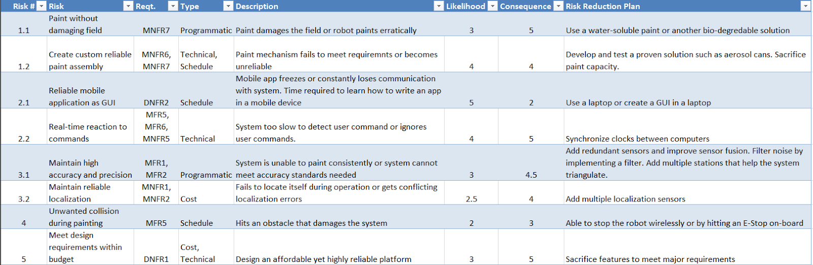

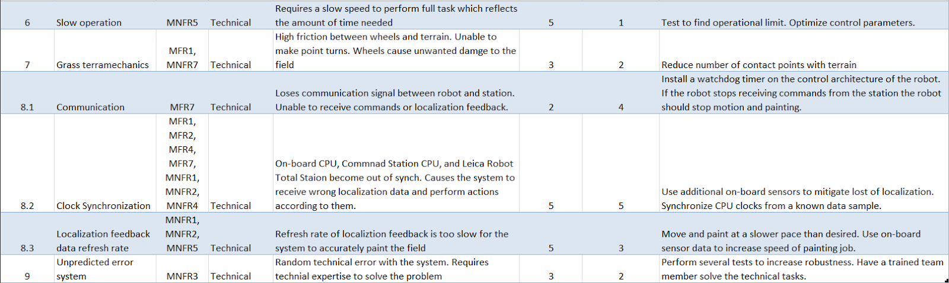

**Figure 1. Risk Management Table**



**Figure 2. Risk Likelihood-Consequence Table**

The table below gives the grading rubric for this assignment.

| **Preliminary Design Review Element** | **Weight** |
| --- | --- |
| 1. Project description | 0.5 |
| 2. Use case | 1 |
| 3. System-level requirements | 1.5 |
| 4. Functional architecture | 1 |
| 5. Cyberphysical architecture | 1 |
| 6. System/subsystem descriptions | 2.5 |
| 7. Current system status | 2.5 |
| 8a. Project management: Work Breakdown Structure | 1 |
| 8b. Project management: Schedule | 0.8 |
| 8c. Project management: High-level test plan | 2 |
| 8d. Project management: Budget | 0.7 |
| 8e. Project management: Risk management | 1.5 |
| 9a. Length | 1 |
| 9b. Intelligibility (incl. format), flow, demeanor, audience connection | 2 |
| 9c. Handling of Q & A | 1 |
| **Total:** | 20 |